**­­**

**­­­­­­­**

**LAB # 01**

|  |  |
| --- | --- |
| **SUBMITTED TO­** | **­­­ESHA E NOOR DURRANI** |
| **SUBMITTED BY** | **Muhammad Ayaan Farrukh** |
| **REGISTRATION NO.** | **B24F0488CS035** |

**­**

# **LAB TASK # 01:**

**Write question here.**

**SOURCE CODE:**

|  |
| --- |
| #include<iostream>  using namespace std;  int main()  {  cout<<"My name is Ayaan";  cout<<"My name is Ayaan"<<endl;  cout<<"My name is A\tyaan";  cout<<"7\\6";  } |

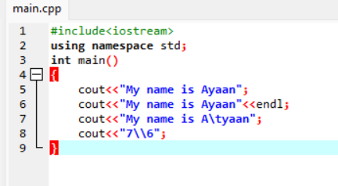**SCREEN SHOT:**

**OUTPUT:**

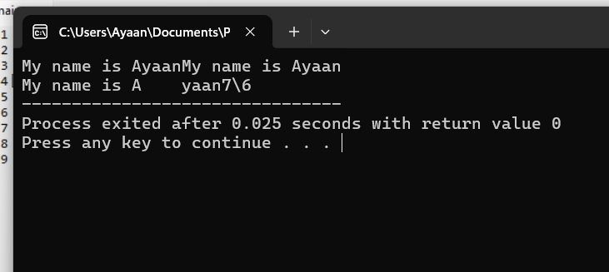

# **LAB TASK # 02:**

­­­­ **Write question here.**

**SOURCE CODE:**

|  |
| --- |
| #include <iostream>  using namespace std;  int main()  { int divide;  int sub;  int Number1;  int Number2;  cout<<"Enter First Number.";  cin>>Number1;  cout<<"Enter Second Number.";  cin>>Number2;  divide=Number1/Number2;  cout<<"Divide="<<divide;  sub=Number1-Number2;  cout<<"Sub="<<sub;  } |

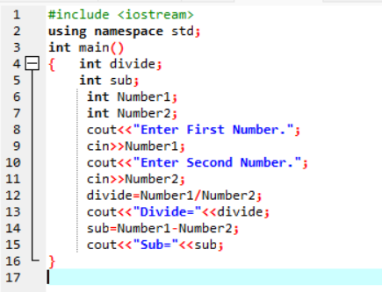**SCREEN SHOT:**

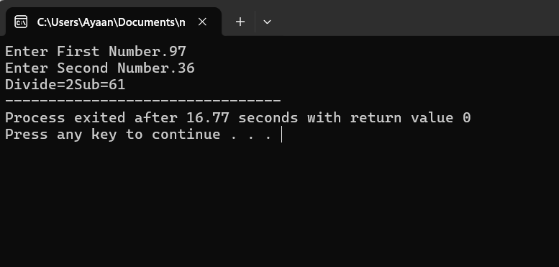**OUTPUT:**